**DAY :1**

Creating Files:



Files on Ls-ltr

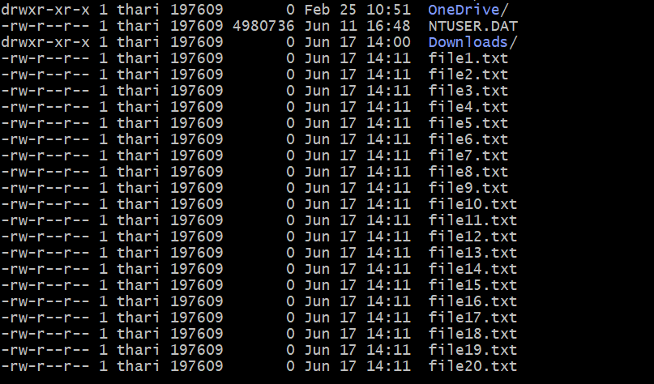

Renaming to .YML

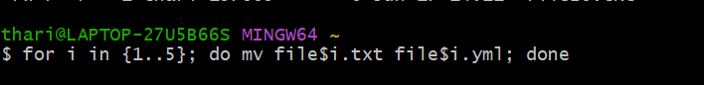

Renamed the below files

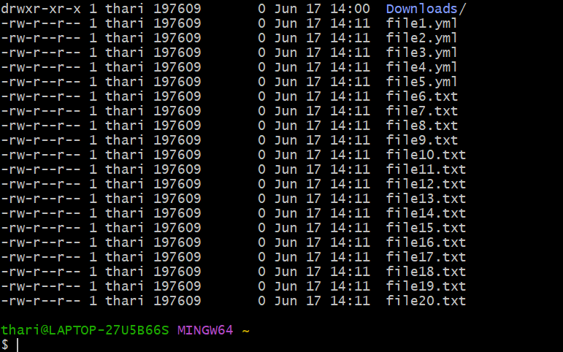

2. listing only the top files

